NAME FIRST AND LAST: |  | DATE: |  |  | TIME AT START: | TIME AT END:
CONDITIONS OF THE WATERFRONT:  - WAVY  - CALM |  |  | WEATHER CONDITIONS:  - SUNNY  - CLOUDY  - RAINY |  | TOTAL # OF PHOTOS TAKEN FOR THIS SITE:
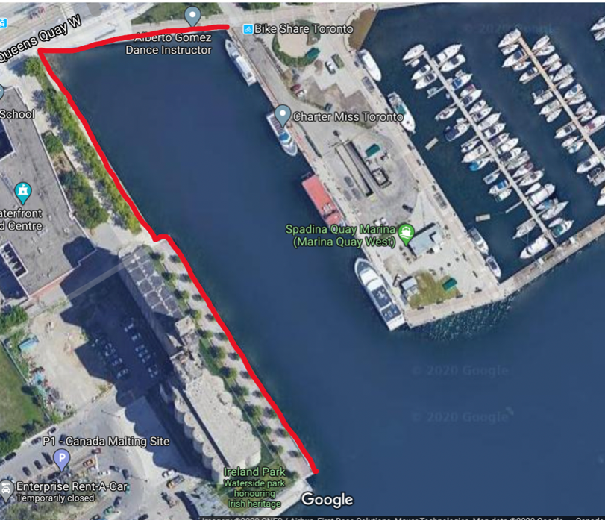
Site 1: Portland Slip
Circle the areas that you’ve identified as a “LARGE DEBRIS PATCH” and label with the corresponding photo number.
~Approx 20min
How much small anthropogenic debris (smaller than a bottle cap) is present within this site? Circle one below:

No small debris

Little small debris

Moderate small debris

Large amount of small debris

VISUAL AUDIT TALLY
ITEM  Example: Straw, bottle cap, fragments, Unknown | TALLY |  |  | NOTES/COMMENTS:

